
Login Instructions for Students
- Go to your school’s main webpage. For instance, students at Gamble Rogers Middle school would go to: https://www-grms.stjohns.k12.fl.us/
- On your school’s main webpage, look at the menu on the left side. You should see something that says, “Clever-Links for Students”. Click on that.
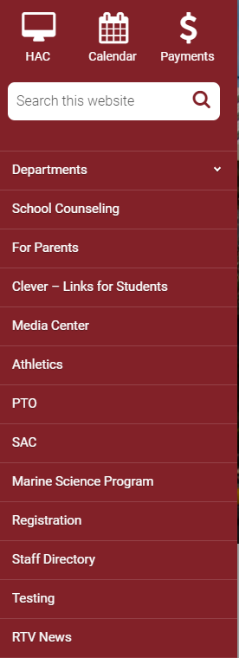
- Click on “Xello” under “Student Applications”. From there, you should be automatically redirected to your Xello account. If not, enter your student number and typical district password to login.
