Provide friendly call services to residents and guests in long-term care; this may include listening, general conversation, friendship and compassionate support.

Virtual Buddy:

Requirements:
Completion of: Application
Completion of Background check (if over 18): Background Check
Phone Interview: Scheduled upon receipt of application and clearance of background check.
Access to: Phone or Computer
Minimum Age to Call Alone: Rising 9th grader
Skills: Good Listening & Communication Skills, and the Desire to Establish One-To-One Relationships
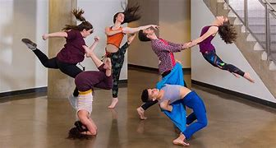
Submit Volunteer Hours: Monthly

Provide a community based entertainment source. Submit prerecorded video of music, dance, singing, How To demonstrations, reading of books, short stories, or poetry. Be creative and share your talents/passions. Not comfortable in front of the camera be the videographer or editor for someone who loves the spotlight.

Entertainment Contributor:

All VIDEOS MUST BE RATED “G”
Frequency of Call: 1-2 times weekly
Duration of Call: Dependent on Participants
Service Hours Awarded: ½ Hour Given for Contact to 15 min., 1 hour given for 16 min. to an hour
Requirements:
Completion of: Application
Access to: Phone or Computer
Minimum Age: All Ages Welcome
Skills: Good Communication Skills, Good Presentation Skills
Submit Volunteer Hours: With Submission of Video
Service Hours Awarded: Minimum 1 hour for Submitted Well Edited Video
Video length: How to / Educational 2-3 minutes, Entertainment as Appropriate for Performance
Video format: mp4
Send Completed Video to: https://brooksvs.wetransfer.com
Include your name and name of performance
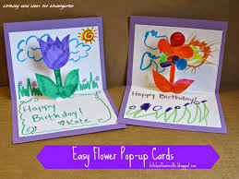
Cards/Art or Stories:
Create cards, letters or short stories to brighten the day of our patients, residents, and staff all who have had to endure a unique and challenging time. It is these little things that can turn someone’s day around.

Requirements:
Completion of: Application
Access to: art or writing supplies
Minimum Age: All Ages Welcome
Skills: Crafting, Basic Spelling, and Writing
Submissions: Minimum of 4 items
Service Hours Awarded: 1 Hour for Every 4 items Submitted
Submit Volunteer Hours: Monthly
Delivery: Volunteer Services/ Brooks Rehabilitation / 3599 University Blvd S. /Jacksonville, FL 32216

Book Club:
Lead the discussion of a book over Zoom. Choose a book and communicate the choice to the group. Conduct a weekly book discussion, of predetermined chapters encouraging everyone’s involvement. Keep book choices to books close to 400 pages to ensure everyone can keep up.

Requirements:
Completion of: Application
Completion of Background check (if over 18): Background Check
Access to: Zoom, FaceTime, or Similar Program
Minimum Age: Rising 9th grader
Skills: Ability to Lead Discussion and Ensure Everyone has a Chance to Participate
Commitment: 4 weeks or One Book
Submit Volunteer Hours: Monthly
Service Hours Awarded: 6 hours per book

Be someone’s accountability partner. Contact them per their exercise plan, and join them via technology as you work out together. They will provide: the exercise plan, including type and duration.
Virtual Work Out Companion:

Requirements:
Completion of: Application
Completion of Background Check (if over 18): Background Check
Access to: Phone or Computer; ability to use Zoom, FaceTime, or similar program
Minimum Age: Rising 9th grader
Skills: Good Communication Skills, Ability to Provide Encouragement, Through Positive Methods, Good Physical Condition
Submit Volunteer Hours: As Completed
Service Hours Awarded: Minimum 1 hour per session

