St. Johns County School District Scholarship List
*Last updated on 9/10/20*
Scholarship Name | Requirements | International/National  /State/Local | Deadline | Need/ Merit-Based | Amount/# of Awards | Scholarship Application/Contact
Voice of Democracy Scholarship  Competition | -High school student  -Write and record an essay on a patriotic theme | National | October 31, 2020 | Merit | State winners compete  for $154,000 in scholarships - with the first place  national winner receiving a $30,000 scholarship | Students can enter directly by submitting the required entry form, along with their essay (and in the case of Voice of Democracy, their recording) to a local  participating VFW Post.  *Entry form on Scholarship Drive*  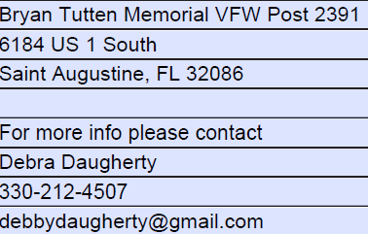
Sapling HR, People Ops and Onboarding Scholarship | -High school student  -Essay where you explain, present, inspire, or otherwise convince us about your great idea for an onboarding program for new employees of a business, and how it would improve their experience. | National | November 1, 2020 | Merit | $1,000 | Julian Hooks julian.hooks25@gmail.com  https://www.saplinghr.com/about/scholarship
Certa Law Personal Injury & Wrongful Death Scholarship | High school student who has had their life altered due to a bodily injury from an automotive or pedestrian accident, be it their own injury, that of a loved one, or an influential individual. | International | December 15, 2020 | Merit | $1,000 | David Warren  david.warren650@gmail.com  https://www.certalaw.com/certa-law-personal-injury-wrongful-death-scholarship/
Equitable Excellence Scholarship | -Demonstrate courage, strength and wisdom as shown by community impact through volunteer service  -Be a high school senior planning to attend an accredited two-year or four-year college or university in the United States.  -Be a United States citizen or legal resident living or claiming residency in one of the 50 U.S. states, District of Columbia or Puerto Rico. | National | December 15, 2020*  *only the first 10,000 applications accepted | Merit | $1.4 million in scholarships ($2,500, $10,000 or $25,000) | Ryan.Goodwin2@equitable.com  (904) 596-7912  https://equitable.com/foundation/equitable-excellence-scholarship
WiseGeek Women in STEM Scholarship | Female high school students who are planning to pursue a degree in science, technology, engineering, or math. | National | December 31, 2020 | Merit | $500 | https://www.wisegeek.com/wisegeek-women-in-stem-no-essay-scholarship.htm  Emma Jackson  emma@wisegeekoutreach.com
US Army ROTC Scholarship | https://offload.goarmy.com/content/dam/goarmy/emm/attachments/ArmyROTCinfo.pdf | National | March 4, 2021 | Merit | Army ROTC provides full tuition and fees (or $10K for room and board) scholarships to over 2000 high school students each year. We intend to continue to sustain that same level of commitment into 2021. In addition to the tuition and fees, the scholarship pays $1200 annually for books and a stipend of $420 per months (for up to 10 months a year.) | usarmy.knox.usacc.mbx.train2lead@mail.mil

