St. Johns County School District
Exceptional Student Education
40 Orange Street
St. Augustine FL 32084
(904) 547-7672
(904) 547-7544 (fax)

Lisa Bell
Director
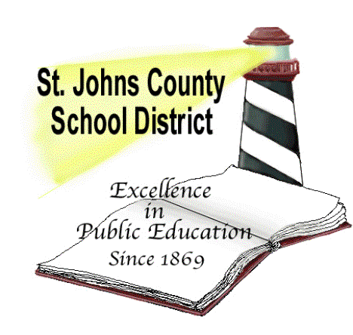

Procedures for Collaborating with Private Instructional Personnel
Observation Only
These procedures are not required when a guardian would like a private provider to observe a student without providing therapy. In this situation, the private provider must gain school access using the School Access Form (https://stjohns.keepntrack.com/apply). Once approved, the private provider signs in as “School Access” and selects “Observation” as the activity. At least 24-hours prior to the observation, the guardian should contact the school administrator to schedule an agreed upon visit. Observations should be scheduled in a manner that minimizes the student’s loss of instruction. During the observation, the observer should minimize interaction with staff and students. Please note that volunteers may not provide therapies or disciplinary action or be alone with students.

Individual Therapy
The intent of the Florida Statute regarding private instructional personnel is to relieve some of the burden that families experience when their children are engaged in private therapy (transportation issues, parents working late, children tired after school). The collaboration of public and private instructional personnel makes room during the school day for therapies to occur.

When a guardian wishes to bring into the school a non-school board employee to provide individual therapy for a student (in addition to any therapy required by an IEP), the private provider must qualify on two counts. First, the private provider must meet criteria based on Section 1003.572, Florida Statute. Second, the private provider must gain school access as a “Vendor” by completing a fingerprinting process and background check through the district office. The first three sections below explain the Florida Statute and St Johns County policy. The fourth section explains procedures for collaboration.

- Section 1003.572, Florida Statute, defines private instructional personnel to mean:
  - Individuals certified under s. 393.17 or licensed under chapter 490 or chapter 491 for applied behavior analysis services as defined in ss. 627.6686 and 641.31098. This includes Registered Behavior Technicians who practice under the supervision of these individuals and who are employed by an enrolled Medicaid provider.
  - Speech-language pathologists licensed under s. 468.1185.
  - Occupational therapists licensed under part III of chapter 468.
  - Physical therapists licensed under chapter 486.
  - Psychologists licensed under chapter 490.
  - Clinical social workers licensed under chapter 491.

- The collaboration of public and private instructional personnel shall be designed to enhance but not supplant the school district's responsibilities under the Individuals with Disabilities Education Act (IDEA). The school as the local education agency shall provide therapy services to meet the expectations provided in federal law and regulations and state statutes and rules. Collaboration of public and private instructional personnel will work to promote educational progress and assist students in acquiring essential skills, including, but not limited to, readiness for pursuit of higher education goals or employment. Where applicable, public and private instructional personnel shall undertake collaborative programming. Coordination of services and plans between a public school and private instructional personnel is encouraged to avoid duplication or conflicting services or plans.

- Private instructional personnel who are hired or contracted by parents to collaborate with public instructional personnel must be permitted to observe the student in the educational setting, collaborate with instructional personnel in the educational setting, and provide services in the educational setting according to the following requirements:
  - The student's public instructional personnel and principal consent to the time and place.
  - The private instructional personnel satisfy the requirements of s. 1012.32 or s. 1012.321.
The provision of private instructional personnel by a parent does not constitute a waiver of the student's or parent's right to a Free Appropriate Public Education under the IDEA.

- Procedures for Collaboration with Private Instructional Personnel:
Step One - Notify School - The guardian must inform the school administrator that they are requesting to bring private instructional personnel into the school.
Step Two – Validation as Private Instructional Personnel – Section 1003.572 Florida Statute describes which certifications/licensure qualify as Private Instructional Personnel. Candidates must contact Danielle Compton (danielle.compton@stjohns.k12.fl.us) describing their certification/licensure along with a brief statement describing the student’s name, school and the type of service that will be provided. The individual providing supervision for a Registered Behavior Technician will need to confirm in writing that they are providing supervision for the RBT and that they are employed by an enrolled Medicaid provider. Once verified, school administration will be notified and applicants will receive an email detailing Step Three.
Step Three – Vendor Approval - All private instructional personnel must complete the fingerprinting process through the St Johns County School District’s Human Resource Department. Right click the following link and select “open hyperlink” to get started: https://www.stjohns.k12.fl.us/screening/process/. After a candidate’s certification/licensure is verified through Step Two, an email is sent detailing the fingerprinting process. Once Step Two and Step Three are completed, the private instructional personnel signs in at the school as a “Vendor” and selects “Private Instructional Personnel” as the activity. Please note that vendor status allows the private instructional personnel to observe the student, be alone with the student and/or provide therapy.

Step Four – Parameters for Collaboration
  - Scheduling – The parent must contact the school administrator to schedule the session at least 24-hours prior to a proposed visit. Visits should be scheduled in a manner that minimizes the student’s loss of instruction and minimizes the amount of disruption to classroom culture.
  - Confidentiality – Private instructional personnel must respect the confidentiality of other students at all times.
  - Solicitation – Solicitation of services by the private instructional personnel is limited to leaving information with school administration.
  - Communication – Any information exchanged between the school and the private instructional personnel must be transferred through the guardian. Even when a “Release of Information” form allows such communication, the school will typically respond through the guardian.
  - Interactions with Students – Private instructional personnel must minimize interactions with other students and may not involve them in the therapeutic process (involving them in group sessions, offering them tangible rewards, correcting them). Private instructional personnel are not to implement any form of disciplinary action or use any form of restraint on students. Any sensory diet or sensory input procedures performed on the student must be provided in a private location.
  - Interactions with Staff – The private entity must minimize interactions with staff that would interrupt the flow of instruction or compromise the teacher’s authority within the classroom. Staff do not collect data or complete forms/assignments for private instructional personnel.

