Practicing Self-Care

What I cannot control (Let go of these things):
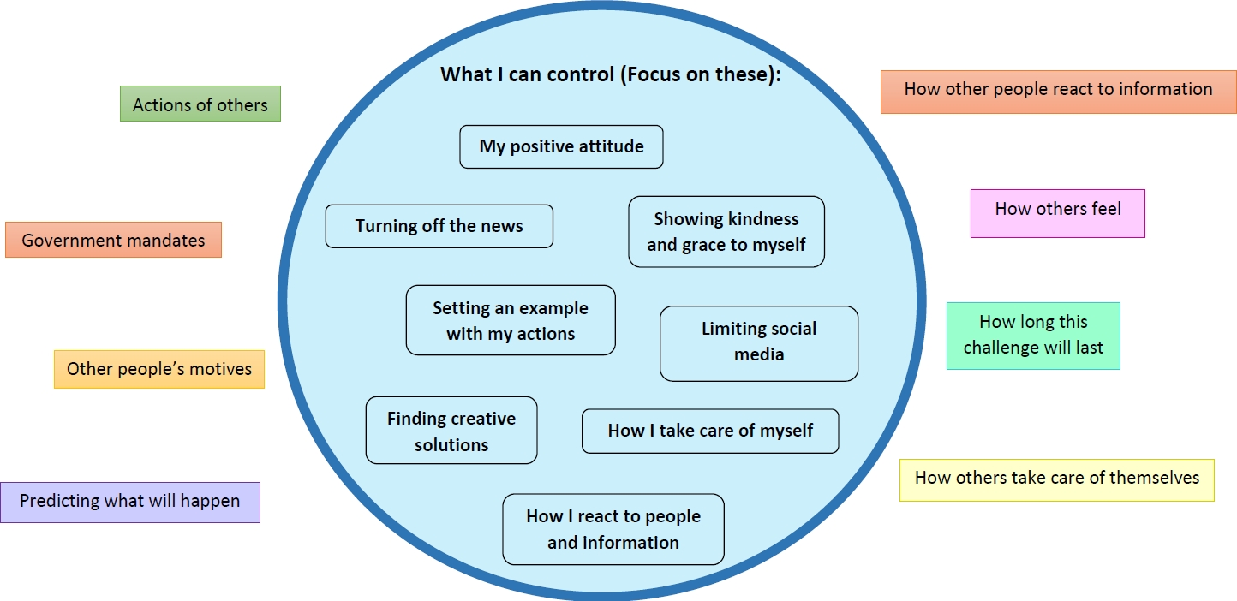
Amy Dujon, M.Ed., covers education and leadership issues for LRP Publications. Copyright 2020 © LRP Publications

