St. Johns County School District

Exceptional Student Education
40 Orange Street

St. Augustine FL 32084

(904) 547-7672

(904) 547-7687 (fax)

Lisa Bell

Director
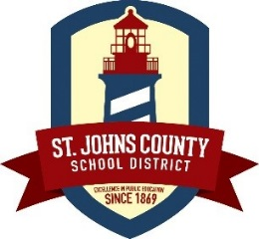

March 14, 2018

Dear Parent or Guardian:
We would like to inform you that your child may be eligible to participate in the John M. McKay Scholarships for Students with Disabilities Program, commonly known as the McKay Scholarship Program. This program was created to provide educational options to parents of students with disabilities. Currently, more than 30,000 Florida students are participating in this program.
By participating in the McKay Scholarship Program, your student may be able to attend a different public school in your district, attend a public school in an adjacent district or receive a scholarship to attend a participating private school.
To be eligible for the McKay Scholarship Program, a student must apply for the program prior to withdrawing from public school. The student must have an Individual Education Plan (IEP), or 504 Accommodation Plan issued under section 504 of the Rehabilitation Act of 1973 (with duration of more than six months), and
- Have been enrolled and reported for funding in a Florida public school (Grades K-12) for the school year prior to applying for a scholarship (foster students may be exempt from this requirement); or
- Have been a pre-kindergarten student who was enrolled and reported for funding in a Florida public school during the school year prior to applying for a scholarship; or
- Have received specialized instructional services under the Voluntary Prekindergarten Education Program from an approved provider pursuant to section 1002.66, Florida Statutes, during the previous school year; or
- Have attended the Florida School for the Deaf and the Blind during the preceding school year’s student membership surveys (Grades K-12).
To find out if your student is eligible, you may apply for the McKay Scholarship Program on the School Choice website at www.floridaschoolchoice.org. Select the McKay Scholarships link, then Parents, and then the link titled Apply for a McKay Scholarship.
To learn more about your child’s educational options, please contact your school district’s Parental Choice Office at 904-547-7712. You may also contact the Florida Department of Education, Office of Independent Education and Parental Choice Information Hotline at 1-800-447-1636, or visit the School Choice website at www.floridaschoolchoice.org and click the McKay Scholarships link.
In order for a student to be eligible for the program, intent to participate in the McKay Scholarship Program must be filed on the School Choice website prior to withdrawing from public school.
The deadline to apply for the first payment period of the 2018-2019 school year is July 3, 2018
McKay Funding for 2017-2018:
Program 111: Grades K-3 |  |  | Program 112: Grades 4-8 |  |  | Program 113: Grades 9-12 |  |  | ESE  Lvl 4  254 | ESE  Lvl 5  255 | Basic  K-3 | Basic  4-8 | Basic  9-12
ESE  Lvl 1  251 | ESE Lvl 2  252 | ESE  Lvl 3  253 | ESE Lvl 1  251 | ESE  Lvl 2  252 | ESE Lvl 3  253 | ESE Lvl 1  251 | ESE Lvl 2  252 | ESE  Lvl 3  253 |  |  | 504 | 504 | 504
$5,936 | $8,150 | $11,489 | $5,608 | $7,823 | $11,162 | $5,291 | $7,506 | $10,845 | $15,453 | $22,433 | $4,942 | $4,494 | $4,498
Please note this letter serves to notify you that your child may be eligible to participate in the McKay Scholarship Program.
This letter does not guarantee your student’s eligibility.
Sincerely,
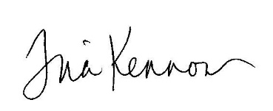
Tina Kennon
Assistant Director for Exceptional Student Education

