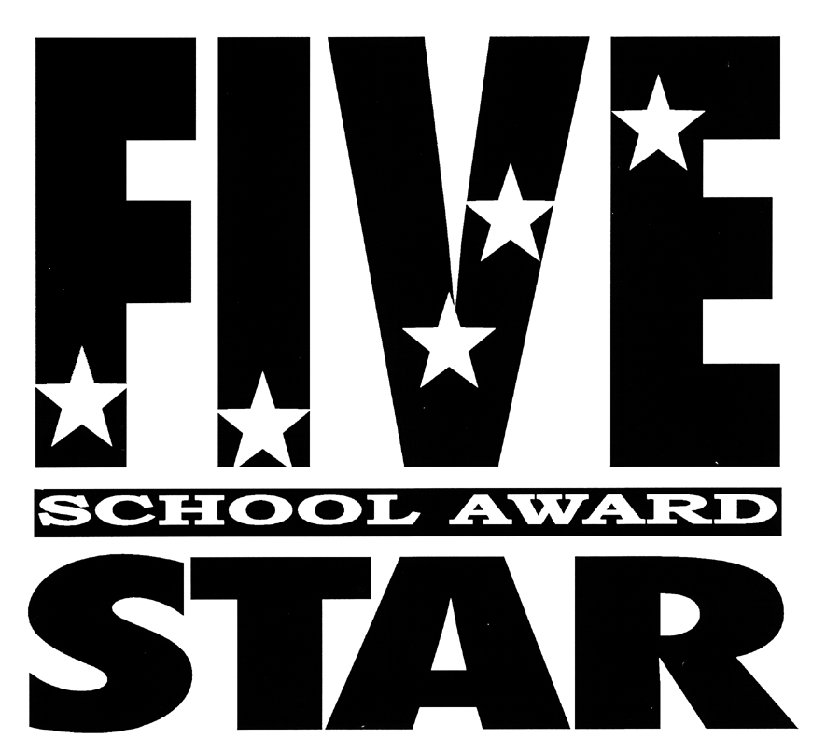

2016-2017 OFFICIAL APPLICATION

K – 12

School improvement and accountability legislation are built upon the active involvement of parents, guardians, business people and other community members in an effort to improve schools in the state of Florida. The legislative intent is to return the responsibility for education to those closest to the students- schools, teachers and families. The Five Star School Award was established to recognize that community involvement is vital to student success.

This symbol of achievement is presented each year to those schools that have shown evidence of exemplary community involvement. Eligible schools are designated annually and must be renewed each year.

In order to qualify for this award, a school must meet 100% of the criteria in the categories of Business Partnerships, Family Involvement, Volunteers, Student Community Service and School Advisory Councils. The school must also have a portfolio that documents compliance with each of the criterion.

SECTION I

Name of School District: ________________________________________________________________

Superintendent: ________________________________________________________________________

Address: _____________________________________________________________________________

City: _____________________ State: ______ Zip: ___________ Telephone: _____________________

District School Volunteer Coordinator: _____________________________________________________

Email: _______________________________________________________________________

Address: _____________________________________________________________________________

City: _____________________ State: ______ Zip: ___________ Telephone: _____________________

Name of School Nominated: _____________________________________________________________

Address: _____________________________________________________________________________

City: _____________________ State: ______ Zip: ___________ Telephone: _____________________

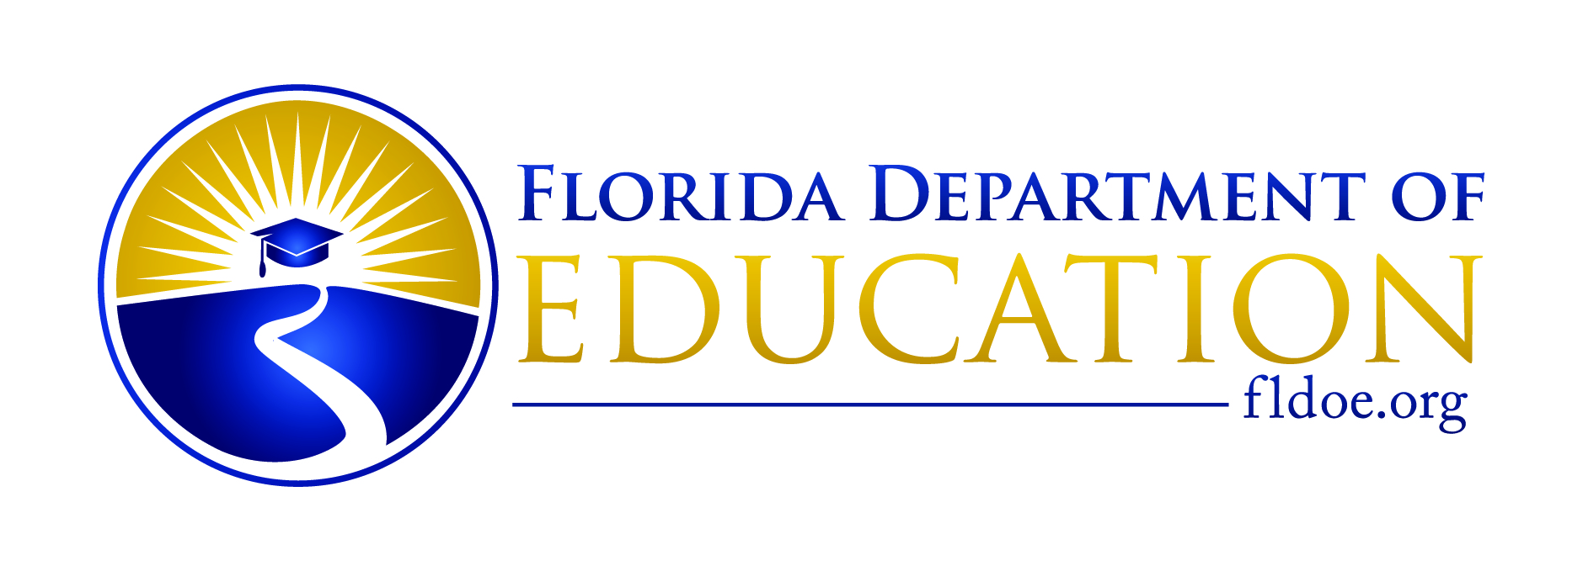
SECTION II

A school must have a grade of “C” or above for the 2016-2017 school year to qualify for the Five Star School Award.

Please check each criterion to indicate accomplishment.

A. Community/Business Partnership
1. ___ Community/business/agency has a jointly-developed plan of partnership activities that is signed yearly.

2. ___ Community/business/agency maintains an ongoing, active relationship with the school.

3. ___ Community/business/agency is involved in the development and implementation of the School’s Improvement Plan.

4. ___ Community/business/agency partnership supports teaching and learning through the donation of human resources and goods/services or financial resources.

5. ___ School designates a community/business partnership coordinator.

6. ___ School provides opportunities for community/business partners to receive orientation and training.

7. ___ Community/business partnership coordinator and school staff receive training during the year on effective use of services by business partners.

8. ___ School provides recognition of community/business partners.

B. Family Involvement
1. ___ School has an active parent organization (e.g., PTA, PTO, Boosters, etc.)

2. ___ Education opportunities are offered to families (e.g., Florida Standards, literacy, career planning, parenting, homework assistance).

3. ___ Focus/discussion/support groups are offered to families (e.g., parenting, drug awareness, safety, violence prevention).

4. ___ School offers joint parent and student training (e.g., academic skills, family reading, violence prevention, financial aid).

5. ___ Family outreach activities are offered through collaborative or facilitated activities (e.g., neighborhood meetings, tutorial services, off-site programs).

6. ___ A minimum of 60% of families are positively involved in the school more than once during the year.

7. ___ School is able to provide evidence of a variety of communication techniques used to communicate with families by teachers and school staff.

8. ___ School ensures that welcome signage is near the entrance and that any interaction with parents creates a climate in which parents feel valued and welcome.

9. ___ School provides parents with current information regarding school policies, practices and both school and student academic performance.

C. Volunteers
(Meets criteria of Golden School Award.)

1. ___ A minimum of 80% of the school staff have participated in school-based volunteer training during the school year.

2. ___ School volunteer coordinator has been designated to provide leadership for the school volunteer program through recruitment, placement, training and supervision of participants.

3. ___ Total number of hours in volunteer service equals twice the number of students enrolled in the school. (Any volunteer activity that contributes to student improvement may be counted.)

4. ___ School provides recognition of volunteers.

D. Student Community Service
1. ___ School provides service learning opportunities to students that focus on identified community needs (e.g., renovating a park, working at election polls, feeding homeless).

2. ___ A minimum of 50% of students are involved in community activities (e.g., pen pals to shut-ins, food drives, cross-school tutoring activities).
.

E. School Advisory Council (SAC)
1. ___ A minimum of eight (8) meetings are held per year. Attendance averages 80% of members.
2. ___ Annual presentation of School Improvement Plan is made to school community after public notice to all stakeholders (e.g., school marquee, flyers, school website).

3. ___ Evidence of ongoing training and/or development of the School Advisory Council is available.

4. ___ School Improvement Plan reflects one new idea that involves the community in its implementation.

5. ___ School Advisory Council participates in the development and/or interpretation of the needs assessment data.
6. ___ Training provided for staff and SAC members on collaborative partnering and shared decision-making.
Documentation of Compliance
A portfolio documenting the accomplishment of each of the criterion is available at the school site.

Yes No

School Impact Data
What proof can you provide that the community's involvement with your school improved the student’ academic work, attendance or behavior? (If necessary, please attach additional sheet.)

Community Involvement Best Practice
Summarize a community involvement promising practice initiated by your school to increase student achievement.
(If necessary, please attach additional sheet.)

We hereby certify the information contained in this application is true to the best of our knowledge and belief.

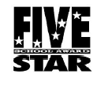
____________________________________________________________ (Signature of Individual Preparing Application Form)

(Title)

(Address)

(Telephone)

(Signature of School Advisory Council Chairperson)

(Signature of Principal)

(Signature of District School Volunteer Coordinator)

(Signature of Superintendent or Designee)

APPLICATION CHECKLIST
Please review the following before returning this application:

__ 1. Have you checked every criterion?
__ 2. Have you clearly identified the school district, district school volunteer coordinator and school nominated?
__ 3. Is the complete address and telephone information provided?
__ 4. Has the application been signed by all required parties?

MAIL to your District School Volunteer Coordinator. The coordinator will verify that all criteria have been met and forward your application to the Florida Department of Education by June 15, 2017.

(Address)

(Telephone)

