ST. JOHNS COUNTY SCHOOL DISTRICT

Professional Development

10 Hildreth Drive

St. Augustine, Florida 32084
Telephone (904) 547-3980 FAX (904) 547-4878

SUBJECT: Professional Development Calendar Instructions

The instructions on how to put the Professional Development Calendar on your Outlook Calendar. Open Outlook and follow instructions.

Step 1: Click on the Calendar Icon at bottom of page.
Step 2: Top of page: Click on Open Calendar. A drop down box will state Address Book. Then
Click on Address Book.

Step 3: A Search Box will open up. Type Professional Development in box, click GO.

Step 4: Make sure to the right of the Search Box the Advance Find box states Offline Global Address List.

Step 5: Box at the bottom of the Search Box click the OK.

Step 6: Under Shared Calendars on left of screen/Look for the Professional Development Calendar.
Check the box to view the calendar.

Open Outlook
5. Click OK box
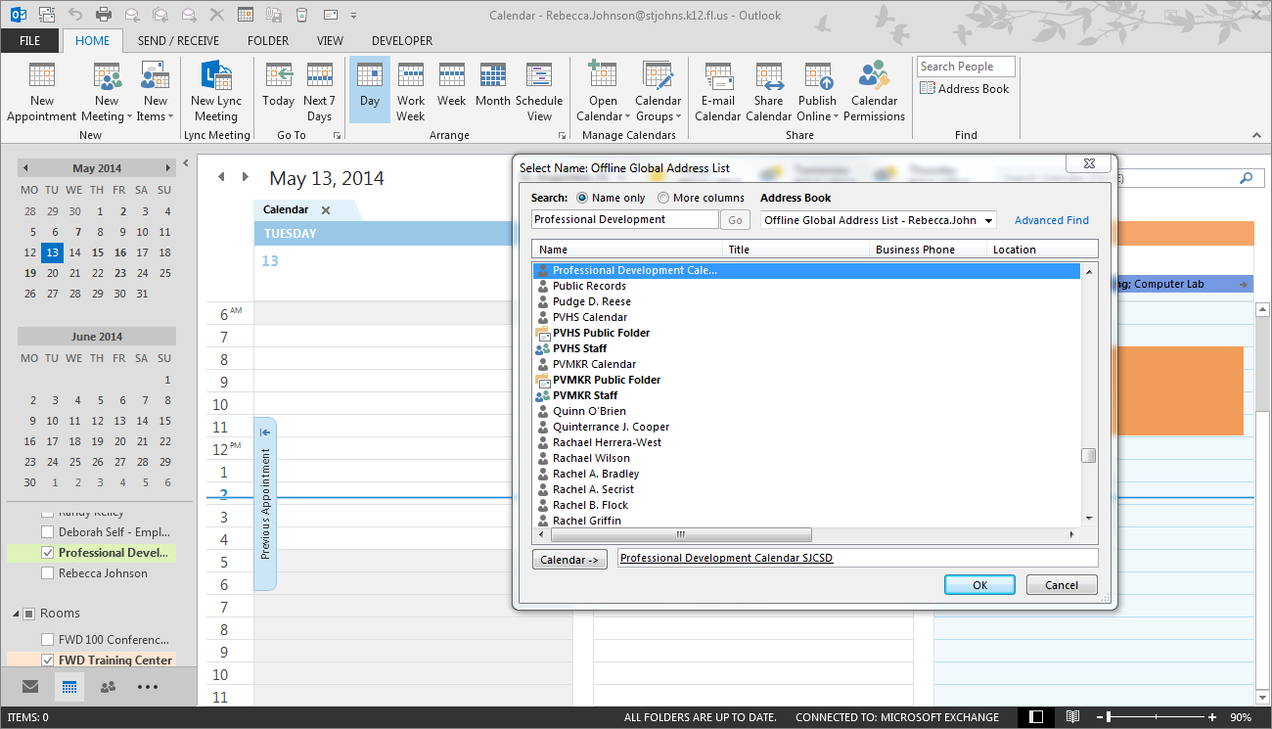
- Click on calendar
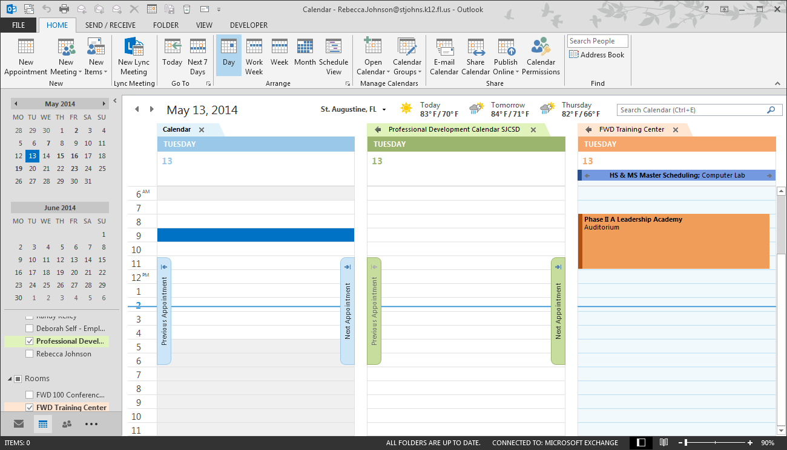

2. Click on Open Calendar. A drop down box will say Address Book. Click on Address Book

3. Type Professional Development in box
And click GO box.
4. Needs to say Offline Global Address List

Professional Development Calendar will look like this.

6. Professional Development Calendar/check box to view calendar
