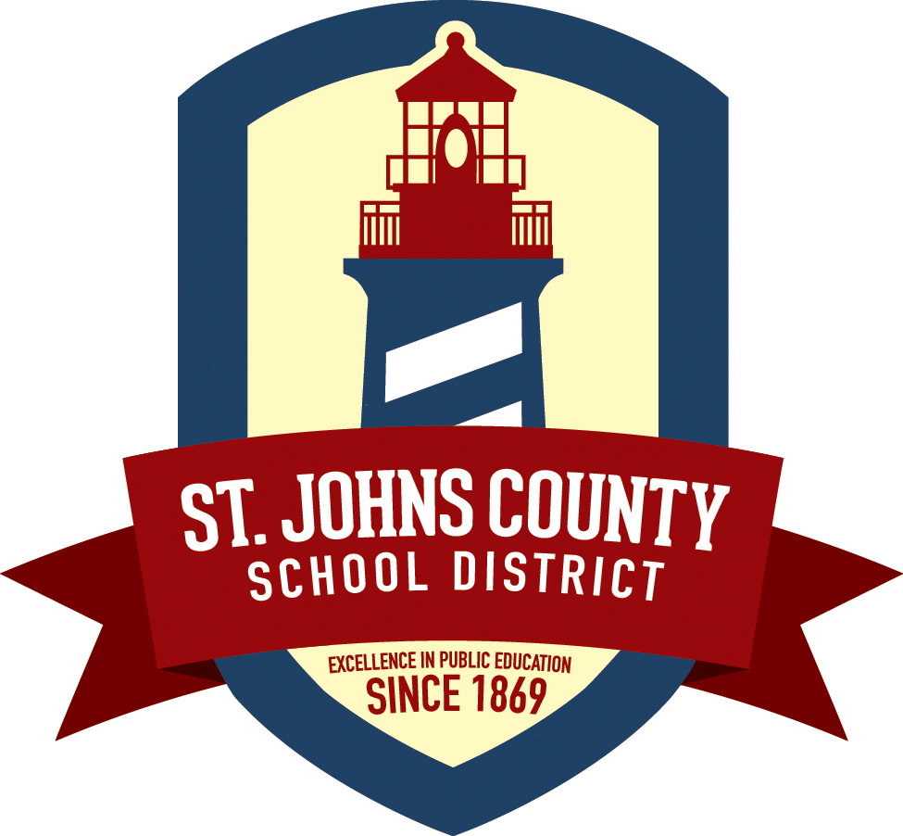
St. Johns County School District
Governmental Relations
Phone: 904-547-7673

2018 SJCSD LEGISLATIVE PLATFORM PROPOSAL

PROPOSAL:

DISCREPANCY:

PRESENT SITUATION:

STATUTORY REFERENCE (If Known):

FISCAL IMPACT (If Known):

SUBMITTED BY: _________________________ __________________________
Name Position

CONTACT: _________________________ __________________________
Email Phone

Please submit platform proposals to Beth Sweeny, Coordinator of Governmental Relations, by Friday, August 18, 2017. Forms can be mailed to 40 Orange Street, St. Augustine FL 32084, or emailed to beth.sweeny@stjohns.k12.fl.us

