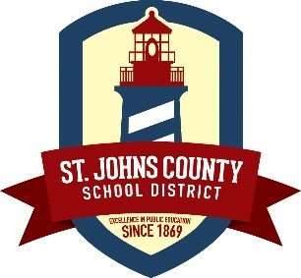 | St. Johns County School District’s New Project SEARCH Site  The St. Johns County School District is proud a new transition program for students with disabilities who are willing and ready to train to work! Project SEARCH St. Johns will provide for students to be fully immersed in the hotel setting to:  - Acquire competitive, transferable, and marketable job skills  - Gain increased independence, confidence, and self-esteem  - Obtain work based individualized coaching, instruction, and feedback  - Develop linkages to Vocational Rehabilitation, Arc, APD, and other adult service agencies
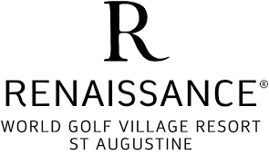 | Renaissance World Golf Village Resort, St. Augustine  As the host business for the Project SEARCH St. Johns, the Renaissance World Golf Village Resort will provide an inclusive environment for students to grow and learn. There are countless opportunities for students to learn vocational skills and thrive. The hotel hosts hundreds of events each year, has beautiful accommodations for guests, and draws people in from all over with the attractions the local area of St. Augustine has to offer, which all help will contribute to diverse internship opportunities for students.  Student interns will spend an entire school year working through three internships with the support of Renaissance employees, a teacher, and skills trainer.
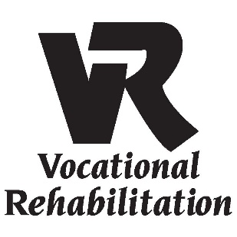 | Vocational Rehabilitation (VR)  VR is a federal-state program that helps people who have disabilities get or keep a job. VR is committed to helping people with disabilities find meaningful careers. A VR counselor will work with the SEARCH team to determine student eligibility for Project SEARCH and VR services, work with the SEARCH team to determine student employment goals, and develop an Individual Plan for Employment (IPE) with each intern.
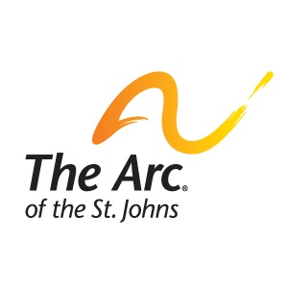 | Arc of the St. Johns  As the Community Resource Provider, Arc of the St. Johns will provide a skills trainer for student interns during their internships. Skills trainers will: guide students through vocational tasks, work with the instructor and business to provide meaningful supports to the intern, build natural supports to increase student independence and inclusion, teach safe practices according to the work environment, model appropriate work behavior, assess student progress and provide feedback to the team, and investigate long-term employment/career opportunities for the students based on interns’ skill sets.

The Project SEARCH Story
In 1996, while working as the Director of the Emergency Department as Cincinnati Children’s Hospital Medical Center, Erin Riehle was frustrated with finding employees for entry-level jobs that involved restocking supplies. While working to identify a solution to eliminating the high turnover rates, Cincinnati Children’s had adopted a major diversity initiative, taking a policy statement from the American College of Healthcare executives, which reads, “Healthcare organizations must lead their communities in increasing employment opportunities for qualified persons with disabilities and advocate on behalf of their employment to other organizations.” Erin wondered if people with disabilities could fill the entry-level jobs she had. Not knowing anyone with a disability, she turned to Great Oaks Career Campuses and the Hamilton County School Board of Developmental Disability Services and asked if her idea was possible. Together with these organizations, the idea of filling a handful of jobs in Cincinnati Children’s Emergency Department evolved into a comprehensive program model, Project SEARCH.
Project SEARCH has grown from one original program site at Cincinnati Children’s to over 435 programs across 45 states and eight countries. Some of the business partners include: Fifth Third Bank, Dow Chemical, The Smithsonian Institute, Medtronic, University of Arkansas Medical Services, Embassy Suites- LaVista, NE, Zoo Miami, Indiana State Government, Emory Midtown Hospital, Drexel University, Xavier University, Kaiser Permanente, McConnell Air Force Base, National Institutes of Health and the University of Rochester Medical Center, and now the newest location at the Renaissance World Golf Village Resort in St. Augustine! Project SEARCH’s primary objective is to secure competitive employment for people with disabilities. SEARCH is driven through collaboration with the following community partners: The St. Johns County School District, Renaissance World Golf Village Resort, St. Augustine, Vocational Rehabilitation, Arc of the St. Johns, and the Agency for Persons with Disabilities.
SEARCH St. Johns Important Dates

- Recruitment for the 2019-2020 cohort will begin in January 2019. Stay tuned to the St. Johns County School District website for more details.

